RIGHT:

**VIEW:**

<ul>

**<a href="#/index.html/questions"><input type="button" value="Back" class="btn btn-primary"></a>**

</ul>

HT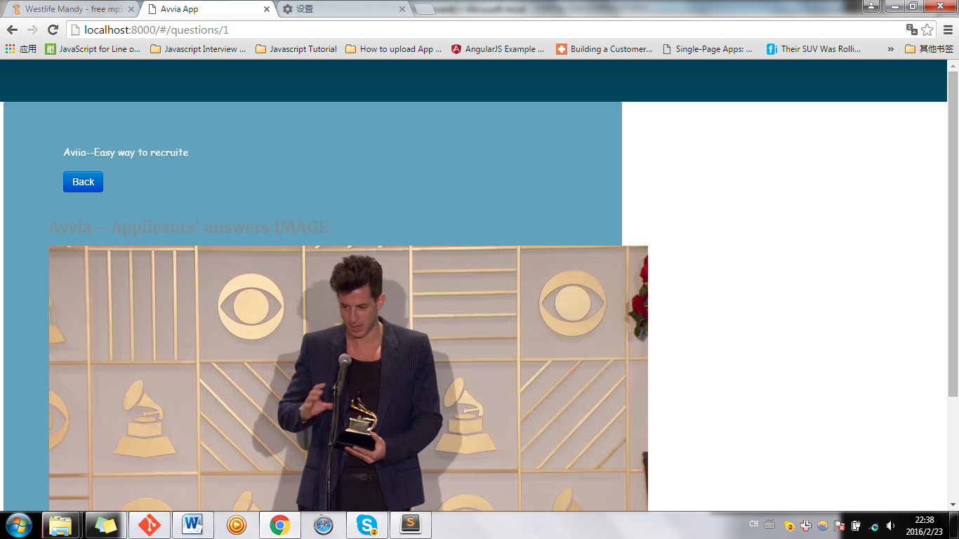

Back to

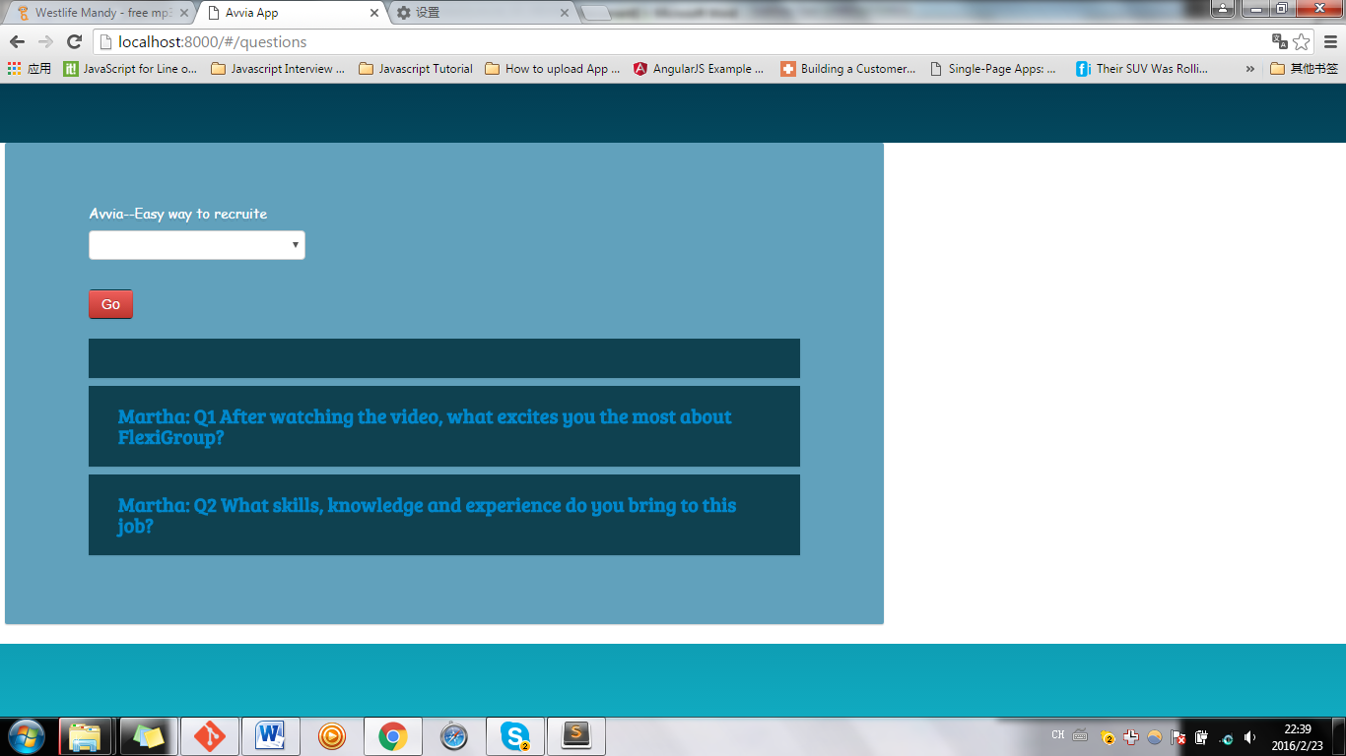

App.js

angular.module('myApp', [

'ngRoute',

'myApp.filters',

'myApp.services',

'myApp.directives',

'myApp.controllers'

]).

config(['$routeProvider', function($routeProvider) {

**$routeProvider.when('/questions', {templateUrl: 'partials/ques_answList.html', controller: 'MyCtrl1'});**

**$routeProvider.when('/questions/:itemRID', {templateUrl: 'partials/ques_answDetails.html', controller: 'MyCtrl1'});**

$routeProvider.otherwise({redirectTo: '/questions'});

}]);

WRONG

View:

<ul>

**<a href="index.html"><input type="button" value="Back" class="btn btn-primary"></a>**

</ul>

Back to



